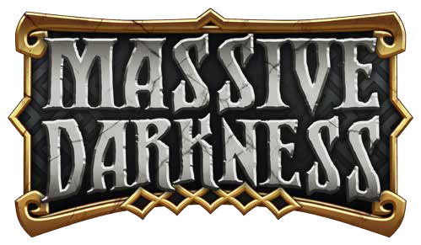

End-Game Revamp

(Unofficial Game Supplement)



MASSIVE DARKNESS – End-Game Revamp

CONTENTS

End-Game Revamp

INTRODUCTION 3

RULE CHANGES 4

STORY MODE 4



Experience and Level 4

Event Cards 4

Lifebringer 4

Death and Resurrection 4

Permanent Death 5

Inventory 5

Transmute 5

Treasure Chests (Door Cards) 5

SETTLEMENTS 6

 SETTLEMENT OVERVIEW 6

Town Size 6

Adventurer’s Guild 6

Marketplace 6

Temple 6

Mage 6

 CAMPAIGN ADVANCEMENT 6

Settlement Phase 6

Party Actions 6

Hero Actions 6

Actions in Detail 6

 PREPARE THE NEXT GAME 7

 BOUNTY OVERVIEW 8

 BOUNTY GOALS 8

 BOUNTY REWARDS 8

BOUNTIES 8

QUESTS 9

DUNGEON BOSSES 10

Step 1: Creating the Boss 10

Step 2: Equipping the Boss 10

Step 3: Preparing the Boss AI 10

Step 4: Spawning the Boss 10

Step 5: Spawning the Boss Guardians 10

SPECIAL BOSS RULES 10



DUNGEON BOSSES 11

 ACTIVATING A BOSS 11

QUESTS 13

2



MASSIVE DARKNESS – End-Game Revamp

INTRODUCTION

3

If you are reading this, odds are you have tried the “Story Mode” introduced in Massive Darkness and found that eventually the game became trivial for you.

This was expressed by many players.

“Quiarcus” from BoardGameGeek got to work coming up with a means of not only making the content more challenging, but also introduced a “Settlement” element to the game.

Instead of just unlocking all of your skills and the best gear willy-nilly – certain elements of the game are gated by the development of your Settlement.

Adventurers now have to go out and not only earn XP, but a new resource: **FAME**. Fame will be used to enhance your settlement, slowly allowing you to be able to use more powerful skills and equipment and take on bigger and better challenges.

Is that alone enough to keep the game enjoyable? Many don’t think so – because Roaming Monsters eventually become almost non-factors in the game with the best skills and equipment.

This leads to “Boss Monsters” – something to make any given adventure more difficult. Think of these Bosses as super-strong roaming monsters that come with guards, more activations, baked-in skills and a sort of “Artificial Intelligence”.

This “AI” comes in different tiers of difficulty – from the base Chief to the Warlord – and with each tier they get more actions they can perform on their activation to threaten your Heroes.

Bosses also have different classes – which vary their AI as well as their baked-in skills and “Signature Skill” to keep you on your toes.

There’s a lot of information this guide and while I am sure it’s not perfect, the goal here is to explain the groundwork of a system that should help you extend your enjoyment of Massive Darkness and provide everything so you can hit the ground running with Settlements and Bosses.

There’s a few new terms we introduce to the game – and this guide will seek to explain them.

Among these terms:

Settlements

Fame

Gold

Arcane Materials

Boss Monsters

Boss AI

Boss Progression

Boss Signature Skills

Melee/Ranged/Magic Boss AI Actions

Support Boss AI Actions

Defense Boss AI Actions

So hold on tight while we work to shed some light on this darkness…

Thanks again to Quiarcus for putting in so much thought and effort to setup the groundwork for this project!





4

MASSIVE DARKNESS – End-game Revamp

RULE CHANGES

**Basi****c Rule Adjustments:**

It is easy to add a lot of complication to a game, but the hope here is to balance out the modifications to the game with changes to make sure the game remains fun, playable and doesn’t drag the pace down.

1. Heroes now only get 2 Actions per Activation and have a Maximum of 4 Actions per Activation (either by equipment, skills or any other mechanism).
2. “Transmute” is no longer used during the normal game.
3. “Trade” is no longer an action. Players may freely GIVE items to other players whether or not they are in the same zone on their turn when they acquire them. They may not receive items from other players.
4. “Reorganize” is still an action, doing so also allows players to give items as per “Trade” above.
5. Players are limited to a number of cards in their backpack equal to their Max Health +1.

STORY MODE



It is easy to add a lot of complication to a game, but the hope here is to balance out the modifications to the game with changes to make sure the game remains fun, playable and doesn’t drag the pace down.

The Story Mode is a game modifier specifically created to slow the experience gain and allow the Heroes to keep their Equipment and Skills from one game to the next. Like in roleplaying games, the Heroes evolve quite slowly, but in a permanent way, during immersive campaigns. You can then play your own epic sagas, taking an active part in the destiny of daring beginners turning into legendary heroes as they go fight through several adventures.

The Story Mode is played with the normal rules, with the following exceptions and specifics.

**Experience and Level**

* The Story Mode uses the MicroXP track of the Hero Dashboard. Every time a Hero should gain an Experience Point using normal rules, he gains a MicroXP instead. Spending 5 XP Points earns a standard Experience Point. This happens automatically once the MicroXP track reaches 5.

NOTES: *Signatures may be used by spending MicroXP. Whenever two Heroes of more have the same amount of XP, use their MicroXP amount to decide which one has the most Experience on the board.*

* A Hero’s Level is set by the highest Skill he has permanently acquired. This is used for several factors in Story Mode.

* A Hero cannot permanently acquire a skill higher than the Adventurer’s Guild of their Settlement allows.

* During a quest, Heroes may acquire skills beyond the level allowed by the Adventurer’s Guild, but these skills are automatically lost at the end of the quest and no experience is refunded.

* Each quest starts at the level corresponding to the highest level among the Heroes. Flip down any lower level tokens on the map. The quest level will remain at this point until a Hero explores a tile with a level token that is higher, at which point that becomes the current level.

**Event Cards**

* In Story Mode, when an Event Card references the current level, this is considered to be the highest level token in a tile occupied by a Hero. For any other purposes, follow the rules for Current Level as described.

**Lifebringer**

* For the first quest, the Lifebringer is setup in view of all players with 2 health tokens on it. These tokens are lost once used and do not refresh between quests. Additional health tokens may be acquired for the Lifebringer by making donations at the Temple during the Settlement Phase.

**Death and Resurrection**

* At the start of every round, players may resurrect dead Heroes by using the power of the Lifebriner. For each Hero you choose to resurrect, remove one token from the Lifebringer’s card and Roll C +2 and heal the Hero that many wounds and stand them up in the zone they were killed in.

* The Hero also loses 5 MicroXP. If they do not have 5 MicroXP, set their MicroXP to 0 and the Hero loses 1 regular XP. If thiswould cause the Hero’s XP to fall below 0, set it to 0 and discard an equipped item. If the hero has no items equipped, for the rest of the quest their Maximum HP is reduced by 1.

* If there are Heroes that need to be resurrected and there are no tokens left on the Lifebringer – this is considered a PERMANENT DEATH.



*WHY SO FAST?*

One of the key challenges is balancing “reality” versus “time”. Some elements of the game might lack a logical justification – but are done for the sake of keeping the game fast and fun!



**Permanent Death**

Should a character need to be resurrected and there are no Lifebringer tokens, the following Hero does the following:

* Remove all skills learned.

* Discard all items equipped and in their backpack

* Set all XP counters to 0

At the Settlement Phase, this Hero may be restarted or changed out for a new Hero/Class. They can choose 2 pieces of starting equipment in preparation for the next quest.

NOTES: *If you choose to play Permadeath, a Quest is not immediately lost when there are no tokens left. The remaining players must exit through the exit token (or starting token if there is no exit token) or suffer the same fate as the fallen Hero!*

**Inventory**

* Heroes receive Starting Equipment on their first quest only.

* Heroes may only equip and use equipment cards up to 1 level above their current level.

* Artifacts are considered to be Level 5.

* Heroes can only carry a number of cards in their backpack up to their Maximum Health +1. Additional cards must be discarded immediately.

**Transmute**

* Heroes can no longer perform Transmute actions.

* Transmute is a Skill performed by the Mage in the Settlement and is used to generate Arcane Materials.

**Treasure Chests (Door Cards)**

* When a door card is drawn, place treasure chests normally.

* Whenever chests are picked up, follow this list:

* The first chest contains 2 gold.

* The second chest contains 1 arcane material.

* The third chest contains a treasure card equal to the tile level -1 to a minimum of 1.

* Special chests contain a treasure card equal to the tile level.



*WHY SO DEADLY?*

Permadeath sounds severe – but keep in mind as the Settlement grows, having a Hero wiped is just a thematic setback as the game really is more about FAME than XP.

RULE CHANGES



MASSIVE DARKNESS – End-Game Revamp

5



SETTLEMENTS

 SETTLEMENT OVERVIEW

Instead of the normal “Town Phase”, this revamp seeks to introduce a new series of mechanics to help keep Story Mode interesting instead of just a made-dash to the best equipment.

Heroes adventure to acquire FAME which is used to upgrade their SETTLEMENT, which unlocks higher skills and other features of the revamp – it is broken down as such:

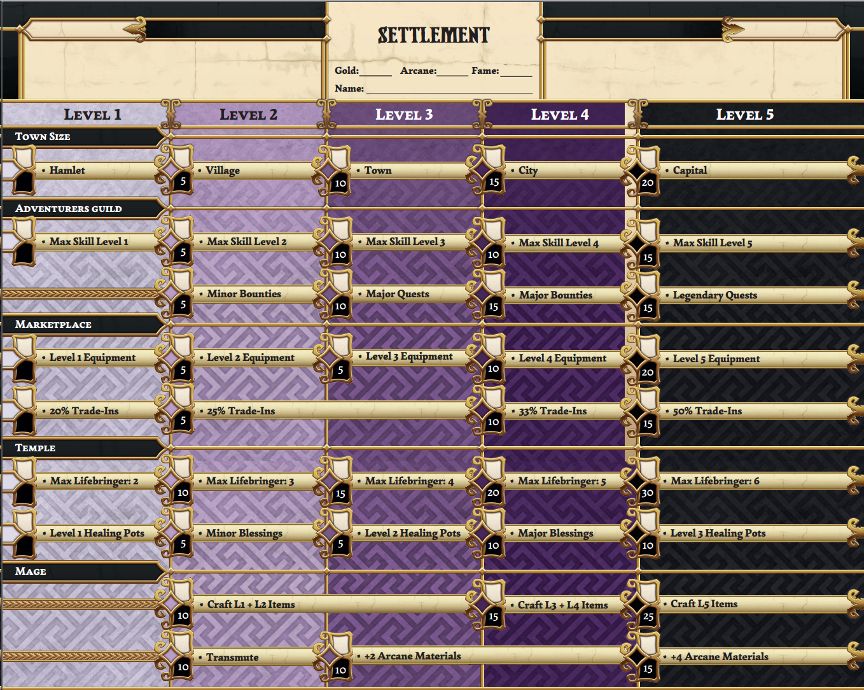

Figure 1: Sample Settlement Sheet

**Town Size**

As Fame is spent, the Settlement becomes larger. The larger the Town, the better upgraded the other facilities can become. No other element can be a higher level than the Town Size.

**Adventurer’s Guild**

The Adventurer’s Guild controls the maximum level of skills Heroes can permanently have as well as it provides access to BOUNTIES and QUESTS.

**Marketplace**

The Marketplace controls the maximum level of equipment Heroes can permanently have as well as it provides the ability to sell excess equipment for gold, as well as potentially purchasing new items.

**Temple**

The Temple controls the maximum number of tokens that can be on the Lifebringer at any given time. It also provides for Potions and Blessings to be acquired.

**Mage**

The Mage is the only means that items can be transmuted into Arcane Materials – and to craft items from those Materials.

 CAMPAIGN ADVANCEMENT

In story mode, players play through either the Official campaigns provided by CMON or using the Random Dungeon mechanics created by Quiarcus.

* If they win a Quest, the group receives 3 Fame.

* If they lose a Quest, the group receives 1 Fame but each Hero must set their MicroXP to 0.

* If the group defeats a Lesser Roaming Monster during the quest, they receive 1 Fame (per quest).

* If the group defeats a Greater Roaming Monster during the quest, they receive 2 Fame (per quest).

* If the group acquires an Artifacte during the quest, they receive 2 Fame (per quest).

**Settlement Phase**

Between quests, Heroes return to their Settlement. They get some rest, heal their wounds, while word of their adventures spreads through the countryside, drawing more people to help their Settlement grow.

**Party Actions**

During this phase, the group collectively can do the following:

* Upgrade the Settlement (Spend FAME for Skills)

* Acquire a Bounty (If available)

* Acquire a Quest (If available)

**Hero Actions**

During this phase, Heroes can do 2 of the following:

* Train at the Adventurer’s Guild

* Buy in the Marketplace

* Sell in the Marketplace

* Replenish the Lifebringer

* Pray at the Temple

* Purchase Healing Potions at the Temple

* Transmute at the Mage

* Craft at the Mage

**Actions in Detail**

* Upgrade the Settlement: FAME is spent similar to XP to acquire skills on the Settlement Sheet However, you cannot upgrade other paths in the Settlement beyond the level of the Town Size.

* Acquire a Bounty: Assuming your group has unlocked minor or major bounties, your group can undertake one as defined in the Bounties section.



6

MASSIVE DARKNESS – End-game Revamp



* Acquire a Quest: Assuming your group has unlocked major or legendary quests, your group can undertake one as defined in the Quests section.

* Train at the Adventurer’s Guild: A Hero can spend XP to permanently learn skills on his Class Sheet up to the maximum level defined by the Adventurer’s Guild of their settlement. Any skills which are learned that exceed the level of the Adventurer’s Guild must be removed and no XP is refunded.

* Buy in the Marketplace: A Hero may purchase items from the Marketplace. Items that are available are based on the following chart:

|  |  |  |
| --- | --- | --- |
| Item Level | Number of Items | Cost in Gold |
| 1 | Marketplace LVL x3 | 20 |
| 2 | Marketplace LVL x2 | 30 |
| 3 | Marketplace LVL x2 | 40 |
| 4 | Marketplace LVL x1 | 60 |
| 5 | Marketplace LVL x1/2 | 100 |

Marketplace Level is determined by what level Equipment has been unlocked in the Marketplace.

* Sell in the Marketplace: A Hero may sell items to the Marketplace in exchange for Gold. By default, items only sell for 20% of their Cost in Gold. This can be improved by learning the higher Trade-in value skills in the Settlement.

* Replenish the Lifebringer: Lifebringer tokens are essential to help avoid Permanent Death. Thankfully the Temple will sell tokens for 25 Gold each, but you can not have any more tokens on the Lifebringer than are allowed by the relevant skill in the Settlement’s Temple.

* Pray at the Temple: Assuming the Temple has been upgraded at the Settlement, a Hero may Pray to the Gods at the Temple, and if accompanied by an appropriate donation, their blessings may fall upon him as he draws a card from the appropriate deck.

Minor Blessings: 30 Gold

Major Blessings: 75 Gold

* Purchase Healing Potions at the Temple: A Hero may purchase a Healing Potion from the Temple up to the maximum level the Temple has been upgraded to at the Settlement.

Level 1 Potion: 15 Gold

Level 2 Potion: 30 Gold

Level 3 Potion: 45 Gold

Select the Potion from the appropriate Treasure Deck and shuffle it afterwards.

* Transmute at the Mage: Assuming the Mage has been upgraded at the Settlement, a Hero may have the Mage transmute items for him. Three items are required for a Transmute – and the lowest level item determines how many Arcane Materials are received:

|  |  |
| --- | --- |
| Item Level | Arcane Materials |
| 1 | 9 |
| 2 | 13 |
| 3 | 17 |
| 4 | 22 |
| 5 | 28 |

* Craft at the Mage: Assuming the Mage has been upgraded at the Settlement, a Hero may have the Mage craft an item for him. Arcane Materials are spent to draw 4 items from the appropriate level Treasure Deck. The Hero selects one to keep, returning the other three and shuffling the deck.

|  |  |
| --- | --- |
| Item Level | Arcane Materials |
| 1 | 15 |
| 2 | 30 |
| 3 | 45 |
| 4 | 70 |
| 5 | 100 |

* If they win a Quest, the group receives 3 Fame.

* If they lose a Quest, the group receives 1 Fame but each Hero must set their MicroXP to 0.

* If the group defeats a Lesser Roaming Monster during the quest, they receive 1 Fame (per quest).

* If the group defeats a Greater Roaming Monster during the quest, they receive 2 Fame (per quest).

* If the group acquires an Artifact during the quest, they receive 2 Fame (per quest).

 PREPARE THE NEXT GAME

At this point, the party is ready to head out on the next adventure – whether it is a Quest from the MD Rulebooks, a Random Dungeon, a Quest they took at the Adventurer’s Guild or whatever awaits them!

SETTLEMENTS



MASSIVE DARKNESS – End-Game Revamp

7



 BOUNTY OVERVIEW

Bounties are basically time-sensitive kill quotas the Party can undertake to earn bonus Gold and Fame. They come in two varieties:

* Minor Bounties: These are unlocked at Level 2 in the Adventurer’s Guild and allow bounties against up to Level 3 Mobs or Lesser Roaming Monsters

* Major Bounties: These are unlocked at Level 4 in the Adventurer’s Guild and allow bounties against any Level Mobs or Greater Roaming Monsters.

To generate a list of available bounties at the Settlement, perform the following:

* Draw three cards from any allowable Guard Decks – they can be from the same deck or different ones.

* Draw two cards from either the Lesser or Greater Roaming monster deck according to the quality of Bounty the party wishes to undertake.

* The group can only take on a single Guard and a single Roaming Monster bounty at any given time – however they are not obligated to take any that arise.

 BOUNTY GOALS

|  |  |  |
| --- | --- | --- |
| Target | QTY | Time |
| Minor Guard | (P + B) x5 Minions | B+1 |
| Minor Agent | (1/2P + B) Agents | B+2 |
| Lesser Roaming | (1/2P + B) Roamers | B+1 |
| Major Guard | (P + C) x5 Minions | B+1 |
| Major Agent | (1/2P + C) Agents | B+2 |
| Greater Roaming | (1/2P + C) Roamers | B+1 |

Target: What the object of the bounty is.

QTY: How many of the target must be killed.

P: Party Size

1/2P: Party Size divided by 2 (rounded up)

Time: How many quests the Party has to accomplish the Bounty before it is considered a failure.

 BOUNTY REWARDS

Once the time has expired, refer to the following chart for the rewards:

|  |  |  |  |  |
| --- | --- | --- | --- | --- |
| Target | Successful | | Failure | |
| MINOR | GOLD | FAME | GOLD | FAME |
| Guard | 1+L/ea | 1 | 1/ea | -1 |
| Agent | 3+L/ea | 2 | 3/ea | -1 |
| Roaming | 25 | 3 | 5 | -2 |
| MAJOR | GOLD | FAME | GOLD | FAME |
| Guard | 2+L/ea | 2 | 1/ea | -2 |
| Agent | 4+L/ea | 3 | 3/ea | -3 |
| Roaming | 50 | 6 | 10 | -4 |

Gold rewards: 1+L/ea means 1 plus the level of the Minions or Agent you were after in gold each. A bounty for L5 Goblins could be quite rewarding!

BOUNTIES



8

MASSIVE DARKNESS – End-game Revamp



MASSIVE DARKNESS – End-Game Revamp

9

QUESTS

This space reserved for information about Quests =)



10

MASSIVE DARKNESS – End-game Revamp



DUNGEON BOSSES

Dungeon Bosses can only be encountered during Quests and come in three difficulty levels: **Chief**, **War Chief** and **Warlord**.

**Chiefs** are the weakest of the Bosses and are most commonly found during “Minor Quests” (Levels 1-2).

**War Chiefs** are more powerful than Chiefs and are only available during “Major Quests” (Levels 3-4) and “Legendary Quests” (Level 5).

**Warlords** are the most powerful Bosses and are only evee encountered during a Legendary Quest.

Each Boss consists of a Roaming Monster Card coupled with a Dungeon Boss Class card. These should be selected PRIOR to the start of the Quest:

**Step 1: Creating the Boss**

When determining the Roaming Monster, base this on the Party’s level. If they are Level 1-3, use a Lesser. If they are Level 4-5, use a Greater.

Both the Roaming Monster and the Dungeon Boss cards can be chosen deliberately or at random.

**Step 2: Equipping the Boss**

Based on the level of the party, draw equipment cards from the appropriate level treasure deck until you find an item the Boss can equip and benefit from. Return all of the other items back to the deck and shuffle it.

**Step 3: Preparing the Boss AI**

Based on the difficulty of the Boss, they will execute either 3, 5 or 6 actions when they Activate. The first action is always a Signature Skill (as symbolized by the “S” icon in each section underneat the “Class Progression” section of the Dungeon Boss card.

As you can see in the example here – the Butcher has the “Prime Cut” Signature Skill – and then as a War Chief would take the following actions:

Attack Action

Defense Action

Attack Action

Defense Action

So when the Boss Activates, you would draw cards from the respective Boss AI decks and execute them in turn.

NOTES: *If you end up with a Roaming Monster that can perform multiple types of attacks, select cards from the decks as the players decide!*



Figure 2: Butcher Boss Monster Class Card

**Step 4: Spawning the Boss**

Based on the difficulty of the Boss, his starting HP is as such:

|  |  |
| --- | --- |
| Boss Level | Health Pool |
| Chief | Roaming Monster x2 |
| War Chief | Roaming Monster x2 |
| Warlord | Roaming Monster x3 |

So if you have a Hellsbane Greater Roaming Monster as a War Chief Butcher – he would have 12 HP per Hero in the party.

**Step 5: Spawning the Boss Guardians**

Bosses are difficult enough on their own, but to make things worse – they don’t travel alone. Spawn 2 Guards at the current level and place them in the same Zone as the Boss.

SPECIAL BOSS RULES



* All Bosses are immune to Stun.

* If a Boss is present on the board at the start of the Enemy Phase, they are activated before any other enemies.

* If a Boss skill or action cannot be completed for any reason, they are executed up to the point of failure and then move on to their next action.

 ACTIVATING A BOSS

* When a Boss activates it does not follow the standard enemy activation rules, but instead follows its own set of AI cards.

* The Boss will follow the AI routine defined on their Dungeon Boss class card each turn. They will perform the instructions once to completion.

* The AI routine always starts with the Boss’s Signature Skill. This will always target a Hero in the Boss’s zone unless otherwise stated.



MASSIVE DARKNESS – End-Game Revamp

11



DUNGEON BOSSES



10

MASSIVE DARKNESS – End-game Revamp



MASSIVE DARKNESS – End-Game Revamp

9

This space reserved for information about Quests =)

QUESTS

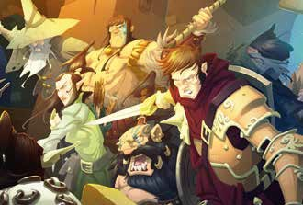

MASSIVE DARKNESS - RULES

STORY: THE LIGHTBRINGERS’ LEGACY

*Our great-grandparents won, not because they were stronger, but thanks to dedication, cooperation, and lore . The best blacksmiths allied with the best enchanters to create superior weapons and armor . Then, the best warriors led the final charge against the Darkness . These champions were nicknamed the Lightbringers, as they brought hope, light, and a burning justice to the world .*

*Their savage foes could do nothing against the combined might of*

*believed in the rule of nature over civilization, of might over law, of night over day . A brutal war began with the clash of royal armies . It ended seven years later with everyone, from the peasants to the kings, fighting for survival .*

*to find out by myself . I don’t want the war to start again . I need proof for all to see . I need glory . I need gold .*

*Claim your legacy, and join us on the brink of Darkness .*

*Massive Darkness* is a cooperative board game for one to six play- ers, age 14 and up. As a team, players agree on a fantasy quest to undertake. Each of them chooses a hero, then the whole party descends into underground lairs and corridors. Prowling in the darkness, the heroes fight guards and monstrosities, claim legendary weapons, and earn experience until they deserve to be called Lightbringers.

The basic goal is to achieve the objectives set by the chosen quest. Players can either play each Quest as a standalone adventure or they can choose to play in Story Mode and watch their heroes gradually evolve throughout the campaign.

*WHY SO DARK?*

Darkness is both a mysterious antagonist and an environ- mental ally in the game, and it shows on the tiles. Darkness plays a major role in the game: sooner or later, even the heirs to the Lightbringers have to hide in the shadows to play deadly hide-and-seek with their dreadful foes.

Enemies of all kinds, from goblin war parties to roaming mon- sters, are controlled by the game itself, using a simple set of rules. Your heroes can battle them in hand-to-hand, ranged, or even magic combat. Explore the dungeon, defeat your enemies, and claim their potent weapons to survive the next challenge!

5



MASSIVE DARKNESS - RULES

SETUP

**1.**choosing the tutorial (P. 40), then playing the Quests in the

**3.**type name on the back, as well as a dedicated color. Once

**Choose a Quest.** If this is your first game, we recommend

**Sort the game cards by type and Level.** Each card bears its

indicated order to follow the story. Experienced players can play a past Quest again with different conditions or create a Quest on their own using the modular tiles and various tokens.

**2.Place the tiles and tokens as indicated by the Quest.**

sorted by type (and Level, if relevant), each pile is shuffled and placed facedown near the board.

* Set aside the **Starting Equipment** cards. Your Heroes will quickly get rid of these basic items to get much more potent toys!
* Set aside the **Artifact** cards. Artifacts are legendary magical items. They are usually Quest objectives. In the right hands, they are game changers.

6

Many items help identify your game cards. They can prove useful in sorting your cards and applying specific game effects.

***Box logo. All cards featured in Massive Darkness’ core box bear this symbol. Each expansion bears its own symbol.***

All cards have a code with their type and number. This clarifies any doubt on the type and lets you know immedi- ately any card you may miss.

A: Artifact RM: Roaming Monster

D: Door SE: Starting Equipment

E: Event T: Treasure

G: Guard



MASSIVE DARKNESS - RULES

* Sort the **Guard** cards by Level and shuffle each Guard deck. Guards form the numerous war bands your Heroes battle in the underground tunnels. They’re made up of either Mob groups, with a Boss leading several Minions, or the terrible Agents. De- feat them all to get Treasure cards!
* Sort and shuffle the **Treasure** cards in the same way as the Guard cards. The evil folks have stolen, forged, and gathered a great amount of treasures for their nefarious goals. Claim these weapons and turn them against your enemies!

7



MASSIVE DARKNESS - RULES

**5.**acter you will play. Take the matching miniature. Take a

**NOTE:** *Heroes can’t change their chosen Hero Class during a cam- paign . The selection is permanent until the next campaign .*

8



MASSIVE DARKNESS - RULES

GAME OVERVIEW

*Massive Darkness* is played over a series of Game Rounds, which go as follows:

HEROES’ PHASE

The First Player takes his Turn, activating his Hero.

A Hero can initially perform up to 3 Actions per Activation. Each can be used to execute various tasks toward the Quest’s comple- tion: moving around the board, battling Enemies in various ways, taking game objectives, finding treasure, or exchanging equipment with fellow Heroes.

After the Hero has finished all of his Actions, any Enemies he attacked (and are still left standing) may immediately try to counter-attack him!

Once a player has resolved his Hero’s Activation (and any possible Counter-Attacks), the player to his left takes his Turn, activating his Hero in the same manner. The Heroes’ Phase ends when all players have completed their Turn.

The Heroes’ Phase is explained on P. 25.

ENEMIES’ PHASE

Enemies come in all shapes and sizes, from the lower Minions to the horrifying Roaming Monsters. Their behavior on the board is governed by a couple of rules used to resolve the Enemies’ Actions during this Phase.

Enemies move around the board, patrolling or actively looking for the heroic interlopers. Of course, they also fight, using bows, claws, swords, and even magic, to make the Heroes’ lives harder. Good news: the strongest Enemies carry the precious Treasures the Heroes seek to complete their Quest. Bad news: those Enemies often know how to use them. So, to get your fabled enchanted sword, you’ll first have to defeat a brute pointing it at you!

The Enemies’ Phase is explained on P. 28.

EXPERIENCE PHASE

Heroes can spend their hard-earned Experience Points (referred to as “XP”) to get new Skills. Their effects are applied as soon as the corresponding Level is reached in the game.

In Standard Mode, unspent Experience Points are lost, and acquired Skills reset for the next Quest. If you wish to keep them from one Quest to the next, allowing players to see their Hero party evolve throughout their own epic saga, you must play in Story Mode (see page 38).

The Experience Phase is explained on P. 31.

EVENT PHASE

As the Round draws to a close, the First Player draws an Event card. It is read aloud and the related game effects are applied.

The Event Phase is explained on P. 32.

END PHASE

The End Phase marks the end of the Game Round. Many game effects stop during this Phase. The First Player hands the First Player token to the player on his left. The latter will be the First Player for the next Game Round. Another Game Round can then begin.

The End Phase is explained on P. 33.

WINNING AND LOSING

Massive Darkness is a cooperative game, so players win or lose as a team. The game is won when the Quest objectives are met. The game is lost when the Quest objectives can no longer be met or when a Hero needs to be resurrected but the Lifebringer has no tokens left (see P. 18).

11

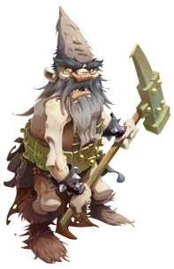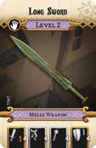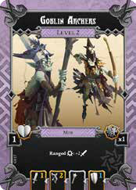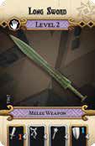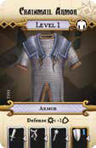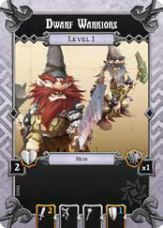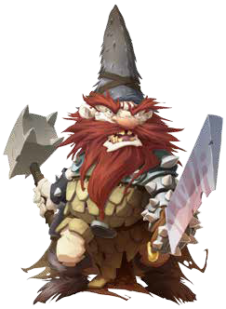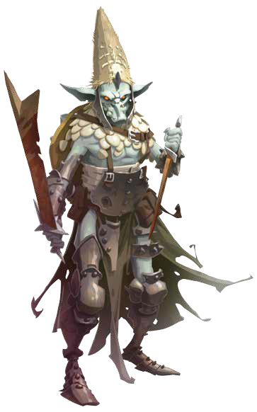

MASSIVE DARKNESS - RULES

**EXAMPLE 1:** *Ariel wants a Level 5 Equipment . She discards 1 Level 2 card and 1 Level 3 card and takes a Level 5 Equipment card from the Town Market .*

* A Hero can carry an unlimited amount of Equipment cards during a Quest, and some Equipment may be kept from a Quest to the next. However, a Hero’s Inventory is limited to 6 Equipment cards at the **start** of any Quest (including no more than 1 Artifact), after the Town Market phase.

**EXAMPLE 2:** *Carl wants a Level 3 Weapon and a Level 1 Healing Potion from the Town Market . ALevel 4 cardwouldbeenoughtotrade for that, but he doesn’t have 1, so he discards his Level 5 Equipment and takes both cards from the Town Market .*

**Campaign Advancement**

In Story Mode, players play through the whole campaign in order, Quest after Quest (or randomly, if they prefer).

**IMPORTANT:** *During the Town Market phase, Heroes may discuss and freely trade items between them, before trading with the Town Market .*

* If they win a Quest, they advance to the next one, going through a Town Market Phase in between.

**GET READY**

At the end of the Town Market Phase, perform the following:

* All Heroes are fully healed.
* Heroes can trade and reorganize their Inventory for free.
* Each Hero must leave the Town Market with no more than 6 cards in his inventory, including no more than 1 Artifact. Any excess cards are discarded.
* In case a Hero only has high-Level cards, which might not be usable at the start of the next Quest, he may freely trade any of his cards for Starting Equipment cards.
* If they lose a Quest, each Hero loses any Micro-XP he might have, and must immediately discard his Inventory down to no more than 6 cards (including no more than 1 Artifact). Players may then choose to try the failed Quest again or move on to the next:
  + If they redo the Quest, they *do not* go through a Town Market Phase. Heroes may choose to replace any of their Equipment with Starting Equipment cards before starting the Quest again.
  + If they move on to the next Quest, they go through the Town Market Phase normally before undertaking the next Quest.

**Town Market Phase**

Between a Quest and the next, your party comes back to town to get some rest, heal wounds, share information, and enjoy the spoils of war. Your Heroes can also buy and sell Equipment at the town market! The Town Market Phase is resolved at the beginning of each Quest, starting from the second.

Your party is ready to start the next Quest on a fresh note!

**SETUP**

To prepare the Town Market, follow those steps:

* Draw as many Level 1 Treasure cards as the number of Heroes.
* Draw as many cards as the number of Heroes, from the Trea- sure deck of the same Level as the lowest-Level Hero.
* Draw one card for each Hero equal to their respective Level. All of these cards make up the Town Market, which is available to all Heroes. *(If a Trap or Luck card is drawn, discard it and draw another card) .*

**TRADE**

Each Hero can perform each of the following trades *once*:

**Trading Equipment for XP:** Discard 1 Equipment card from your Inventory to get half of its Level (rounded up) in Experience Points (not Micro-XP).

**EXAMPLE:** *Josh discards 1 Level 5 Equipment card and gains 3 XP .*

**Trading Equipment for other Equipment:** Discard 1 Equipment card from your Inventory to get 1 card from the Town Market, OR discard 2 Equipment cards from your Inventory to get 1 card from the Town Market, OR discard 1 Equipment card from your Inventory to get 2 cards from the Town Market, as long as the combined Level of the cards discarded is equal to or greater than the combined Level of the cards acquired.

39

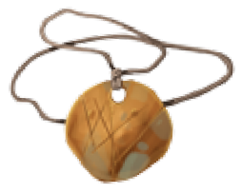

MASSIVE DARKNESS - RULES

INDEX

Activation . . . . . . . . . . . . . . . . . . . . . . . . . . . . . . . . . . . . . . . . . . 11, 28

Actor 12

Agent 23

Ally 12

Artifact 37

Chamber 13

Class Sheet . . . . . . . . . . . . . . . . . . . . . . . . . . . . . . . . . . . . . . . . . . 18, 31

Combat 33

Combat Type 22

Consumable 20

Corridor 13

Counter-Attack 27

Defense 22

Dice . . . . . . . . . . . . . . . . . . . . . . . . . . . . . . . . . . . . . . . . . . . . . . . . 16, 33

Door 26

Enchantment. . . . . . . . . . . . . . . . . . . . . . . . . . . . . . . . . . . . . 22, 34, 53

End Phase 33

Enemies’ Phase 28

Enemy 20

Event Phase 32

Experience Phase 31

Experience Point 31

Guard 23

Guardian 24

Health . . . . . . . . . . . . . . . . . . . . . . . . . . . . . . . . . . . . . . . . . . . 18, 21, 35

Hero 17

Heroes’ Phase 25

Inventory 19

Item 20

Level 15

Lifebringer 9

Line of Sight 14

Micro-Experience Points 38

Minions . . . . . . . . . . . . . . . . . . . . . . . . . . . . . . . . . . . . . . . . . . . . 21, 23

Mob 23

Mob Rules 36

Move . . . . . . . . . . . . . . . . . . . . . . . . . . . . . . . . . . . . . . . . . . . . . . . 15, 26

Objective Token . . . . . . . . . . . . . . . . . . . . . . . . . . . . . . . . . . . . . 27, 37

Pillar 37

Resurrection 18

Roaming Monster 23

Room 13

Shadow Mode 13

Signature 27

Skills 52

Starting Equipment 6

Story Mode 38

Stun 37

Trade 27

Transmute 27

Treasure 27

Weapon 19

Zone 13

55

*CREDITS*

**GAME DESIGNERS:**

Raphaël Guiton, Jean-Baptiste Lullien, and Nicolas Raoult

**EXECUTIVE PRODUCER:**

Thiago Aranha

**ART:**

Edouard Guiton, Antonio Mainez, Nicolas Fructus, Eric Nouhaut, Mathieu Chow Cheuk, and Giovanna Guimarães

**GRAPHIC DESIGN:**

Mathieu Harlaut, Louise Combal, and Marc Brouillon

**SCULPTORS:**

Juan Navarro Perez, Alex Aragorn Marks, Edgar Ramos, Edgar Skomorowski, and Arnaud Boudoiron

**WRITING**

Bryan Steele

**DEVELOPMENT:**

Alexandru Olteanu (lead), Marco Portugal, Fel Barros, Michael Shinall, and Fabio Tola

**PUBLISHER:**

David Preti

**PLAYTEST:**

Luiz Alvarez, Gabriel Antonini, Eduardo Buffardi, Fabio Castro, Nahuel Dias, David Doust, Rodrigo Esper, Júlia Ferrari, Rodrigo Fock, Patrícia Gil, João Gois, Thiago Gonçalves, Fabul Henriques, Isadora Leite, Renato Lopes, Lucas Martini, Bruno Meira, Jared Miller, Diego Moraes, Carolina Negrão, Fernando Nogueira, Flávio Oota, Luiza Pirajá, Bruno Podolski, Caio Quinta, Sergio Roma, Ricar- do Senaha, Paulo Shinji, Daniel Silva, Rodrigo Sonnesso, Danilo Sparapani, Livia Sparapani, Eduardo Vilela, and Amanda Watson

© 2017 CMON Productions Limited, all rights reserved. No part of this product may be reproduced without specific permission. Guillotine Games logo is a trademark of Guillotine Games Ltd. Massive Darkness, CMON, and the CMON logo are trademarks of CMON Global Limited. Actual components may vary from those shown. Figures and plastic components included are pre-assembled and unpainted.

Made in China.

**THIS PRODUCT IS NOT A TOY. NOT INTENDED FOR USE OF PERSONS 13 YEARS OF AGE OR YOUNGER.**

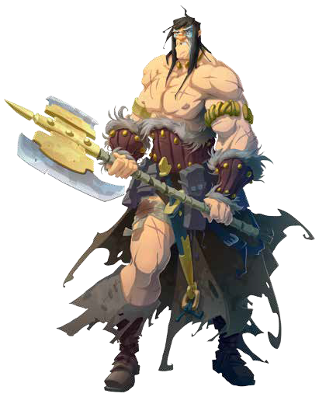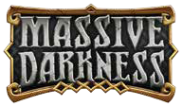

GAME ROUND

COMBA

**Melee:** Range 0

Game rules override this Game Round summary rules.

**1 . PLAYERS’ PHASE:**

**Ranged:** Range 1+

The First Player Activates his Hero. When he’s done, each player in clockwise order does the same, until all Heroes have been Activated. Each Hero has 3 Actions to spend during his Activation, chosen from the following list.

* **Movement:** Spend 2 Movement Points on:
  + **Move:** The Hero moves 1 Zone.
  + **Open a Door:** Draw a Door card for the whole Chamber when it’s first revealed.
  + **Pick Up:** Take all tokens in his Zone.
* **Combat Action:** Magic, Melee, or Ranged.
* **Reorganize/Trade:** Trade with all Heroes in his Zone.
* **Get Up:** The Hero recovers from a Stun effect.
* **Do Nothing:** All remaining Actions are lost.

The following can be performed without spending any Actions:

* **Transmute:** Discard 3 Equipment cards and draw one 1 Level higher than the lowest of them.
* **Signature:** Spend 1 Experience Point to execute it *(once per Activation)*.

**Magic:** Range 1-2

**1.**form a single roll (up to 3 dice of each type).

Add the Attacker’s dice with the Defender’s dice to per-

**2.**trigger the Defender’s Enchantments and, from the

Bam and Diamonds

from the Defense dice may

Attack dice, may trigger the Attacker’s Enchantments. Defense Enchantments are resolved before the Attack Enchantments.

**3.**how many Wounds the Defender suffers. If its Health

Add all Hits

, then subtract all Shields

to determine

drops to 0, it is killed. The Hero is rewarded with the Equipment the Enemy had, plus some XP:

**Counter-Attack:** At the end of his Activation, all surviving Enemies the Hero attacked are activated and try to Attack him.

**2 . ENEMIES’ PHASE:**

All Enemies on the board are activated, performing the follow- ing steps:

**Step 1 -** Try to Attack a Hero. *If they’re unable to, they continue to Step 2 .*

**Step 2 -** Move 1 Zone towards their target.

**Step 3 -** Try to Attack a Hero. *If they’re unable to, they continue to Step 4 .*

**Step 4 -** Move 1 Zone towards their target.

Target priority:

**1:** Hero in Range with most XP.

**2:** Hero in Line of Sight with most XP.

**3:** Hero in a Light Zone with the most XP.

**4:** Starting Zone.

**3 . EXPERIENCE PHASE:**

Spend Experience Points to get new Skills.

**4 . EVENT PHASE:**

Draw and resolve an Event card.

**5 . END PHASE:**

The next player receives the First Player token (in clockwise

order).

**MINION**  **1 XP to the Hero**

**BOSS**  **3 XP to all Heroes**

**AGENT**  **4 XP to all Heroes**

**ROAMING MONSTER**  **5 XP to all Heroes**

T